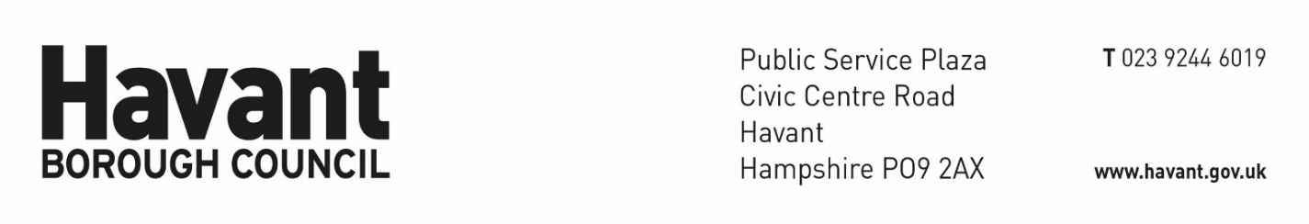
Confirmation of acceptance of Terms of Engagement

Reference No:
Site Address:

I hereby confirm acceptance of Havant Borough Council’s Terms of Engagement for the Building Control Service, with regards to the above Building Regulation application.

Signature of Client or an agent acting for the Client: …………………………………..

Print Name: ………………………………………..

Notes:
- This document, or a similar written confirmation, must be competed and return to the Council to allow any work to be carried out on the application by a Registered Building Inspector.

- Until such time as this written confirmation has been received the Council will not be able to examine any plans submitted with the application, issue a formal decision for the application or carry out any inspections of the work on site.

- It is the sole responsibility of the Client, or an agent acting for the Client, under the Building Safety Act 2022 and associated Regulations to provide this written confirmation.

- The Council will accept no responsibility for any delays caused by the Client not returning this written confirmation.

- This document must be signed by the Client or an agent acting for the Client.

- This document must be returned to Havant Borough Council at bct@havant.gov.uk

