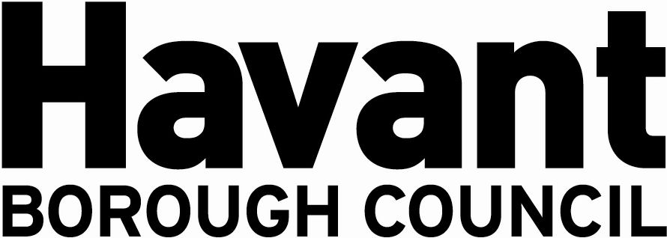

NOTICE OF APPLICATION FOR THE GRANT OF A

PREMISES LICENCE
SECTION 17, LICENSING ACT 2003

We, Malbari Limited Ltd, hereby give notice that we have applied on 05 March 2025 to Havant Borough Council as the Licensing Authority for the Grant of a Premises Licence for the premises known as:

58 West Street
Havant
Hampshire PO9 1PG

The application is to enable:

The on and off sale of alcohol between 11:00 and 23:00 Monday to Sunday.

It is an offence knowingly or recklessly to make a false statement in connection with an application and a person is liable on conviction to a fine not exceeding level five on the standard scale.

Any responsible authority or interested party wishing to make representations on this matter must submit those representations in writing to: LICENSING DEPARTMENT, HAVANT BOROUGH COUNCIL, PUBLIC SERVICE PLAZA, CIVIC CENTRE ROAD, HAVANT, HAMPSHIRE PO9 2AX by 2 April 2025. A register of applications can be inspected at www.havant.gov.uk

This notice must be displayed outside the premises clearly visible from a public place for 28 days starting the day after application is made to the Licensing Authority.

