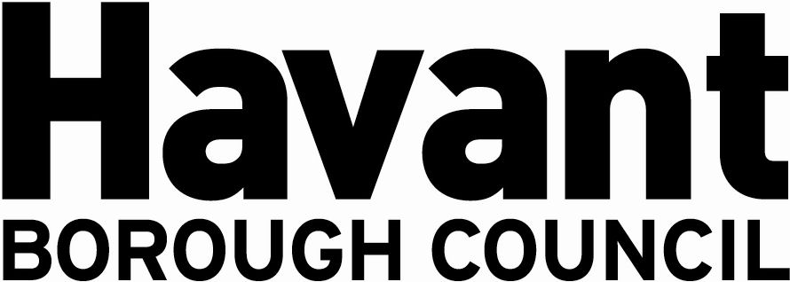

NOTICE OF APPLICATION FOR THE GRANT OF A

PREMISES LICENCE
SECTION 17, LICENSING ACT 2003

We Hayling Island Lions Club (CIO) hereby give notice that We have applied on 13 March 2025 to Havant Borough Council as the Licensing Authority for the Grant of a Premises Licence for the premises
known as:
Eastoke Corner
Seafront
Hayling Island

The application is to enable:
The sale of alcohol and Regulated Entertainment, namely Plays, Films, Boxing/Wrestling, Live Music, Recorded Music, Performance of Dance, anything similar to Live Music, Recorded Music or Performance of Dance
all week between the hours of 09:00 – 22:00
as specified in the application to be provided within the Premises.

It is an offence knowingly or recklessly to make a false statement in connection with an application and a person is liable on conviction to a fine not exceeding level five on the standard scale.

Any responsible authority or interested party wishing to make representations on this matter must submit those representations in writing to: LICENSING DEPARTMENT, HAVANT BOROUGH COUNCIL, PUBLIC SERVICE PLAZA, CIVIC CENTRE ROAD, HAVANT, HAMPSHIRE PO9 2AX by (Date) 10 April 2025. A register of applications can be inspected at www.havant.gov.uk

This notice must be displayed outside the premises clearly visible from a public place for 28 days starting the day after application is made to the Licensing Authority.

