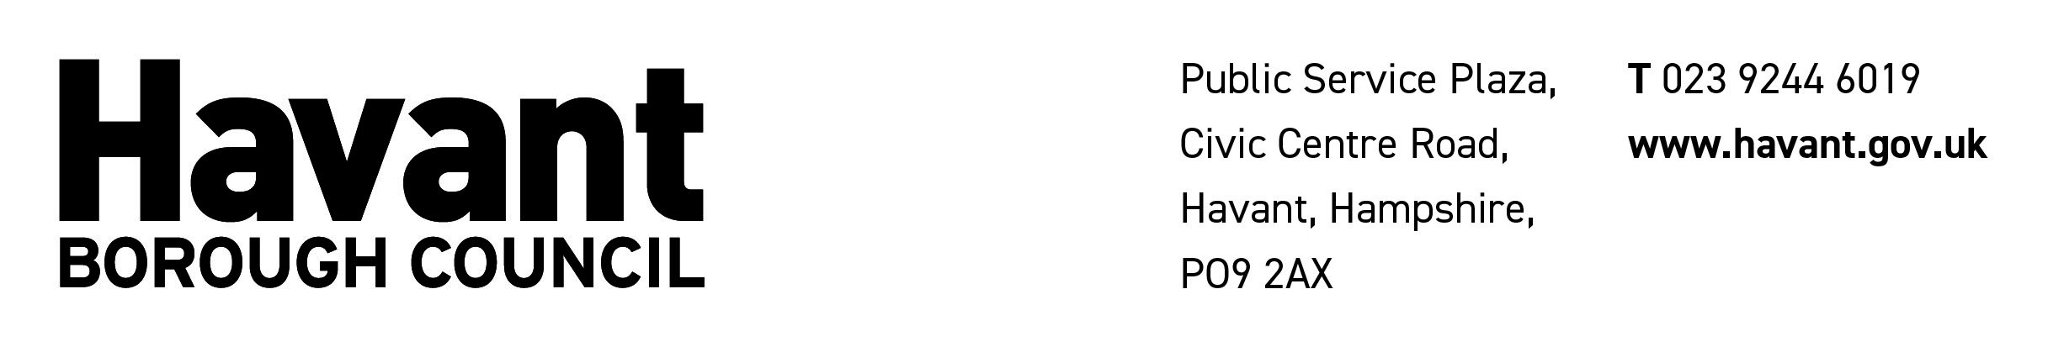

HOUSE TO HOUSE COLLECTION FORM OF STATEMENT

- PERMIT DETAILS

Name of the person to whom the permit was granted …………………………………………………………

Address of the person to whom the permit was granted………………………………………..……………..

……………………………………………………………………………………………………..…………………

Name of the Charity or Fund which is to benefit……………………………………………………….............

Date of collection…………………………………… House to House Collection Permit No…………………

- FINANCIAL DETAILS (PLEASE SHOW NIL ENTRIES)

If money was collected, please complete Section 1 and go to C & D.
If property was collected and sold, please complete Section 2 and go to C & D.
If property were collected and given away, please complete Section 3.

Section 1 – if money was collected

Proceeds of  Collection | Amount in £/p | Expenses and Application of Proceeds | Amount in £/p
From collecting boxes  Interest on proceeds  Other items (please list) |  | Printing and Stationery  Postage  Advertising  Collecting Boxes  Badges/Emblems  Other items (please list)  Payments approved under Reg 15(2)  Disposal of balance (insert details e.g. bank payment)
Total in £/p |  | Total in £/p

Please now go to C and D (or Section 2 if applicable).

Section 2 - if property was collected and sold

Proceeds of  Collection | Amount  £ p | Expenses and Application of Proceeds | Amount  £ p
Sales of property collected  Interest on proceeds  Other items (please list) |  | Expenses incurred during period of account (please list)  (excluding expenses of converting property into cash)  Expenses incurred during period of account for the converting of property into cash  Disposal of balance (insert details e.g. bank payment)
Total (1) | £ p | Total (2) | £ p
Estimated valuation of property collected but not sold (3) | £ p | If the estimated value (3) is not equal to the difference between Total proceeds (1) minus Total expenses (2), an explanation should be provided with this Form of Statement

Please now go to C and D (or Section 3 if applicable).

Section 3 – statement if property was collected and not sold

I certify that to the best of my knowledge and belief all property collected in the collection of which particulars are given above (A.) has been given away or used for charitable purposes (unless found useless and destroyed or otherwise disposed of as rubbish) as follows:

(insert details of disposal of property collected)

………………………………………………………………………………………………………………………………

………………………………………………………………………………………………………………………………

Date………………………. Signed by permit holder…………………………………………………………….

I further certify that the above certificate has been signed by every person responsible for the disposal of the property collected.

Date………………………. Signed by permit holder…………………………………………………………….

- CERTIFICATION BY THE PERMIT HOLDER

I certify that to the best of my knowledge and belief the above is a true account of the proceeds, expenses and application of the proceeds of the collection.

Date………………………. Signed…………………………………………………………….

- CERTIFICATION BY ACCOUTANT OR FINANCIAL PERSON

(This part of the form MUST be signed by one of the following before being returned to the Licensing Office Havant Borough Council, Civic Offices, Civic Centre Road, Havant, P09 2AX or licensing@havant.gov.uk)

- An Accountant or Accounting Technician qualified by examination:
- A Chartered Secretary:
- A Solicitor:
- An Associate of the Institute of Bankers:
- The Manager of a Bank:
- The Manager of a Building Society:

I certify that I have obtained all the information and explanations required by me and that the above statement is in my opinion a true account of the proceeds, expenses and application of the proceeds of the collection.

Date……………………….. Signed ……………………………………Name ……………………………….

Qualifications ………………………………………………………………………………………………………

