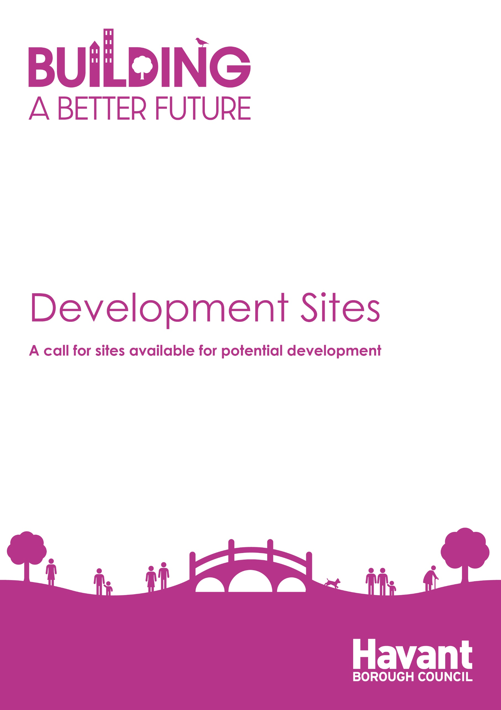

Development Sites
A call for sites available for potential development
For internal use only:
SHLAA ref:
ELR ref:
Date Received:
Date Acknowledged

Please use the following form to submit details of a site that you consider has potential for development. If you need assistance in completing the form please email emma.chisnall@havant.gov.uk.
- Please complete the form clearly and legibly.
- One form should be completed for each potential site.
- Please attach a map clearly showing the precise boundary (in red) of the site that you wish to promote. This should reflect the boundary shown of the relevant Land Registry Title. Potential sites can only be considered if a map is supplied. Please use an appropriate scale (e.g. 1:2,500).
- Please attach the relevant land registry title
- All sites to be allocated in the local plan must be capable of being delivered. It is essential that information on how any known constraints would be overcome are included in your submission. This is particularly necessary if off-site mitigation is needed for any reason
- Please ensure that this form is fully completed, including the declaration.
Please email completed forms to planning.design@havant.gov.uk
Alternatively, you can post your forms to: Planning Policy and Urban Design, Havant Borough Council, Public Service Plaza, Civic Centre Road, Havant, Hants, PO9 2AX.
The information collected in this form will be used by the Council to inform the evidence bases of the Local Plan including the Strategic Housing Land Availability Assessment (SHLAA) and other supporting documents. For more details on how we will use your information, please view the Council’s privacy notice at: Privacy policy | Havant Borough Council and the councils declaration on page 6.

Your Details

Name:
Company/Organisation (if applicable)
Email:

Address:
Postcode:
Telephone Number(s): |  | Mobile
Are you the:
- Landowner
- Developer
- Agent
- Other (please specify)

Ownership

If you are not the landowner, please supply the name(s) and contact details of the owner(s). If you are the landowner, please indicate n/a.
If you are not the owner, has the owner(s) given support for the development of the land? If you are the landowner, please indicate n/a.
Site Details

Site Address including post code:

Site Area (ha):

Developable Site Area (ha):
See figure 1 in the Residential Density paper: https://www.havant.gov.uk/eb41-residential-density-evidence-paper-pdf-19-mb
Current Land Use(s):

Surrounding Land Use(s):

Availability of access to the site:
Relevant Planning History:
Has there been any pre-application enquires in the past and if so, what is the reference?
Development Details

Potential Type of Development
Please indicate the proposed use for the site and provide further details if known:

For mixed use sites, please fill in the boxes below for all applicable uses.

Retail (including shops and food uses) |  |  | Type of use
 |  |  | Floorspace (sq. m)
Housing |  |  | No of houses:
 |  |  | No of flats :
Estimated housing yield (if known)
Commercial |  |  | Type of use
 |  |  | Floorspace (sq.m)
Other (please specify)
NB for any sites proposed for environmental mitigation, please use the separate call for sites form.
Are there any other additional details you would like to tell us about the proposal?

When is this site likely to be developed (if known)? Please tick one only.

In next 5 years  (Apr 2023-Mar 2028) |  | 5-10 years  (Apr 2028-Mar 2033) |  |  | 10-15 years (Apr 2033-Mar 2038)
Please indicate the phasing of the proposed development

Are there any known constraints to development? (Physical constraints, ownership factors, access, contamination, special protection area, market viability etc.):

Any proposals to overcome constraints:

Any other site relevant information:

Declaration

Please read the following disclaimer:
- The information collected in this form will be used by Havant Borough Council to inform the preparation of the Local Plan. By responding you are accepting that all the information within it could be made available to the public.
- The Council must have a full and complete set of information in order to make a determination on whether land should be allocated in the local plan. This includes information on how any known constraints on the site will be overcome, particularly if this requires off-site mitigation. If your site was considered under the now withdrawn Havant Borough Local Plan, there may be commentary on the site within the Inspectors Interim Findings Report. Any identified concerns in the inspectors report must be shown to be able to be overcome in order for any allocation in the new local plan to take place.
- The identification of sites, buildings or areas within any evidence base document does not mean that the Council would grant planning permission for development. All planning applications, including those for residential development will be determined in accordance with the development plan unless material considerations indicate otherwise.
- The inclusion of sites within the Council's evidence base does not preclude use or development of the site for other purposes.
- Any boundaries shown are based on information available at the time of the preparation of the survey. They do not represent an absolute area for any future proposals.
- The evidence base may provide an estimate of when sites may come forward for development. This does not, however preclude applications coming forward earlier than this timescale.
- The evidence base will use the latest information available at the time of the study. The Council does not accept liability for any omissions or factual inaccuracies that may be contained within its evidence base. Applicants applying for planning permission are advised to carry out their own site assessments and analysis.
- Where the site capacity identified in the evidence based is based on the surrounding neighbourhood density, this should not be taken as the level of housing which would be most appropriate for the site. The density of any planning application will be assessed through the normal planning process.
I understand that any comments submitted in response to this request for sites could be made publicly available by Havant Borough Council and will be identifiable to my name or organisation.

Name (print)
Date

Please return this form to planning.design@havant.gov.uk.
Alternatively, you can post your form to: Planning Policy and Urban Design, Havant Borough Council, Public Service Plaza, Civic Centre Road, Havant, Hants, PO9 2AX.

