

Guide to acceptable countersigned photographs for personal licence applications

If you have any questions, please do not hesitate to contact the Licensing Team on 02392 446660 or licensing@havant.gov.uk

What is being certified?
On signing one of your two photographs, the counter-signatory is declaring that the photograph is a true likeness of yourself.

A correctly signed photograph would include on the reverse:
- “I hereby certify that this is a true likeness of (full name of the person in the photograph)”
- A copy of your signature
- Your printed name
- The position of the person signing
- The date
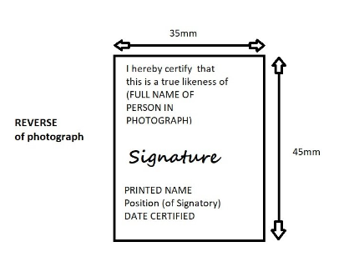
Who can countersign my photographs for application?
- The counter-signatory must hold a professional qualification.
- The counter-signatory may not be a spouse or relative.
- Licensees may not certify photos.

Please note, that although the NLC is classed as a professional qualification, licensees are not acceptable counter-signatories.

Accepted counter-signatories
Accountant
Articled Clerk of a Limited Company
Assurance Agent of Recognised Company
Bank/Building Society Official
Barrister
Broker
Chairman/Director of Limited Company
Chemist
Chiropodist
Christian Science Practitioner
Commissioner of Oaths
Councillor: Local or County
Civil Servant (permanent)
Dentist
Engineer (with professional Qualifications)
Fire Service Official
Funeral Director
Insurance agent (full time) of a recognised Company
Journalist
Justice of the Peace
Legal Secretary (members and fellows of the Institute of legal secretaries)
Local Government Officer
Manager/Personnel Officer (of Limited Company)
Member of Parliament
Merchant Navy Officer
Minister of a recognised religion
Nurse (SRN and SEN)
Officer of the armed services (Active or Retired)
Optician
Person with Honours (e.g. OBE MBE etc)
Photographer (Professional)
Police Officer
Post Office Official
President/Secretary of a recognised organisation
Salvation Army Officer
Social Worker
Solicitor
Surveyor
Teacher, Lecturer
Trade Union Officer
Travel Agency (Qualified)
Valuers and auctioneers (fellow and associate members of the incorporated society)
Warrant officers and Chief Petty Officers

Or persons of similar standing to the above, working or retired, are acceptable as counter-signatories.

